Final Report



BUMK746: Digital Analytics

Sushi Restaurant Performance Analysis Final Report

Team 4

Oluwatosin Afolabi, Reese Habicht, Journey Hudson, Edward Kelly, Dabeluchukwu Ndidi Okigbo, Julia See

Date: May 7, 2026

Honor Pledge:

We pledge on our honor that we have not given or received any unauthorized assistance on this assignment.
This report presents a data-driven analysis of restaurant performance across multiple operational dimensions, drawing on historical transactional records spanning 2015 to 2026. Seven core research questions are examined, covering revenue forecasting, demand drivers, customer spending behaviour, seasonal patterns, product affinities, pandemic impact, and long-term financial outlook. The central finding is that restaurant performance is both highly predictable and primarily shaped by customer volume and temporal factors rather than customer demographics. The business exhibits strong long-term growth, stable margins, and a well-evidenced response to the COVID-19 pandemic. Profit projections through 2026 are positive, and several actionable strategic opportunities have been identified to support continued growth.
Can daily revenue be predicted with sufficient accuracy to support operational planning? To address this question, a Random Forest regression model was trained using five predictor variables: day of week, weekend status, public holiday indicator, customer volume (covers), and prior-day revenue. Evaluated against out-of-sample data, the model achieved a Mean Absolute Error (MAE) of $469.92. Given that average daily revenue ranges between $2,000 and $2,900, this represents a relative error of approximately 16–23%, which positions the model as a reliable instrument for trend-based planning but not for precise day-level budgeting.
Feature importance analysis reveals a consistent hierarchy of demand drivers. Customer volume — the number of covers served on a given day — is by far the strongest predictor of revenue, outweighing all temporal variables combined. This finding carries a direct strategic implication: initiatives designed to increase foot traffic are likely to produce greater revenue gains than those focused on adjusting per-customer pricing. The second most influential variable is prior-day revenue, which captures a demand momentum effect whereby strong performance tends to carry forward into subsequent trading periods. This suggests that promotional activity or operational improvements that generate a single strong day may have compounding short-term benefits.
Beyond these two primary drivers, weekend status, day of week, and holiday designation each contribute meaningfully to the model's predictive accuracy. Together, these temporal variables confirm that the business operates within a structured and foreseeable demand cycle — one that can be anticipated and planned around with reasonable confidence. The Random Forest approach, while less interpretable than linear alternatives, captures non-linear interactions between these variables that simpler models would miss, and is well-suited to the complexity of real-world hospitality demand.

Table 1 — Predictive Model Summary
Variable / Metric | Value
Model Type | Random Forest Regression
Mean Absolute Error (MAE) | $469.92
Average Daily Revenue Range | $2,000 – $2,900
Approximate Relative Error | 16% – 23%
Top Predictor | Customer Volume (Covers)
Second Predictor | Prior-Day Revenue
Table 1. Summary of revenue forecasting model performance and leading demand drivers.

Does customer origin influence per-transaction spending? A natural hypothesis in hospitality analytics is that non-local customers — tourists or visitors less familiar with local pricing alternatives — may spend more per visit than local regulars. To examine this, an independent samples t-test was conducted comparing mean per-transaction expenditure between the two groups. The results did not support the hypothesis. Non-local customers spent an average of $110.16 per transaction, while local customers averaged $110.32 — a difference of just $0.16. The associated p-value of 0.7129 is far above any conventional threshold for statistical significance, indicating that the observed difference is indistinguishable from random variation.
The practical implication of this finding is significant. Marketing strategies premised on attracting non-local or tourist customers in the expectation of higher per-visit spend are unlikely to yield a meaningful revenue premium. Both customer segments behave comparably at the point of purchase, and the more productive focus for revenue growth remains the volume of customers served — regardless of their origin. This finding reinforces the conclusion drawn from the demand driver analysis, which identifies customer volume as the primary lever for revenue improvement.

Table 2 — Spending Comparison by Customer Origin
Customer Segment | Mean Spend per Transaction | p-value
Non-Local Customers | $110.16 | 0.7129
Local Customers | $110.32 | 0.7129
Table 2. Independent samples t-test results comparing per-transaction expenditure by customer origin. No statistically significant difference was observed (p > 0.05).

Are there identifiable seasonal patterns in revenue, and what are their implications for resource planning? Monthly revenue analysis reveals a pronounced and predictable demand cycle. The business reaches its twin performance peaks in July and December, each averaging approximately $2,938 in daily revenue, before declining to its annual trough in January at around $2,005 per day. This represents a revenue differential of roughly $933 — approximately 46% — between the strongest and weakest trading months, a gap substantial enough to have meaningful consequences for staffing, inventory, and cash flow planning if not anticipated.
The July peak is consistent with elevated summer tourism and increased discretionary dining activity. Warmer weather tends to drive higher volumes of both local social dining and visitor activity, creating a natural demand tailwind. The December peak reflects the influence of the holiday season — celebratory meals, corporate functions, and gift-occasion dining — all of which tend to concentrate spending in the food service sector during this period. The January trough, by contrast, reflects a well-documented post-holiday contraction in consumer spending, compounded by reduced social activity in the colder months.
The consistency and predictability of these seasonal patterns means they are readily actionable. Staffing levels, supplier orders, and promotional calendars should all be calibrated to this cycle rather than assuming uniform demand across the year. The transition from December to January in particular warrants proactive management — for instance, through targeted local loyalty offers or prix-fixe promotions designed to sustain cover volumes when organic demand is at its weakest.

Table 3 — Seasonal Revenue Performance
Month | Average Daily Revenue | Classification
July | ~$2,938 | Peak
December | ~$2,938 | Peak
January | ~$2,005 | Trough
Table 3. Average daily revenue for key seasonal periods, illustrating the range between peak and trough months.

What ordering patterns characterise large-party dining occasions, and what commercial opportunities do they present? Analysis of transactions involving parties of four or more guests reveals a set of strong and consistent product preferences. The California Roll is the single most ordered item among large groups, with 57,806 units sold, followed by the Spicy Tuna Roll (45,863), Salmon Nigiri (44,115), Tuna Nigiri (36,653), and Edamame (34,402). The ordering pattern reflects a preference for familiar, shareable items across both roll and nigiri formats, typically accompanied by a light appetiser.
Market basket analysis of co-purchase associations reinforces this picture. The California Roll is most frequently paired with the Spicy Tuna Roll (42,726 co-purchases), Salmon Nigiri (40,876), Tuna Nigiri (33,964), Edamame (31,847), and Miso Soup (26,704). The breadth and volume of these pairings indicate that large parties follow a broadly predictable ordering template rather than making highly varied selections. This consistency is commercially valuable: it suggests that a curated group dining package built around these items would align closely with revealed customer preferences while reducing decision complexity at the table.
Structured group menus present two distinct revenue opportunities. First, they can increase average order value per party by surfacing items — such as Miso Soup or side dishes — that are frequently considered but not always ordered independently. Second, they can reduce service friction and table turn time by streamlining the ordering process for larger groups. High-margin ancillary items such as soups, edamame, and sides are natural inclusions in such packages and should be given prominence in any group dining offer.

Table 4 — Top Items by Sales Volume (Large Parties ≥4 Guests)
Item | Sales Volume
California Roll | 57,806
Spicy Tuna Roll | 45,863
Salmon Nigiri (2 pieces) | 44,115
Tuna Nigiri (2 pieces) | 36,653
Edamame | 34,402
Table 4. Top five items by sales volume for dining parties of four or more guests.

Table 5 — Most Frequent Co-Purchases with California Roll
Paired Item | Co-Purchase Volume
Spicy Tuna Roll | 42,726
Salmon Nigiri (2 pieces) | 40,876
Tuna Nigiri (2 pieces) | 33,964
Edamame | 31,847
Miso Soup | 26,704
Table 5. Items most commonly ordered alongside the California Roll by large parties.

Can the COVID-19 demand shock be identified from channel-level data, and what does it reveal about structural shifts in consumer behaviour? The operational impact of the COVID-19 pandemic is directly legible in the dataset. A pronounced structural break in dine-in order volumes is identifiable commencing during the week of 23 March 2020, consistent with the timing of lockdown measures and mandatory restaurant closures enacted across the operating region. The abruptness and scale of this decline serves as a natural validation of the dataset's integrity — confirming that transactional records are temporally accurate and sufficiently complete to capture major structural events.
The pandemic shock was not merely a temporary suppression of demand; it was accompanied by a durable shift in channel composition. Takeaway and delivery volumes rose sharply as dine-in became unavailable and then cautiously resumed under restricted conditions. While dine-in has recovered meaningfully in the years since 2021, the data suggest that a portion of the pandemic-era shift toward off-premises consumption has persisted, reflecting both changed consumer habits and improved delivery infrastructure. This structural evolution in channel mix has implications for kitchen capacity planning, packaging and delivery cost management, and the design of menu items suited to off-premises consumption. Continued investment in delivery channel capabilities is warranted given the evidence of sustained post-pandemic demand.
How have profit margins evolved over the observation period, and what does the long-term financial outlook suggest? Gross profit margins have remained broadly stable over the observation period, declining modestly from 68.42% in 2015 to 67.32% in 2024 — a contraction of 1.10 percentage points over nine years. While this erosion is not severe in absolute terms, it is consistent with well-documented cost pressures in the food service sector, including sustained food input cost inflation, rising labour expenses, and increased operating overhead. The gradual nature of the decline suggests that the business has managed these pressures reasonably well to date, but without proactive intervention, incremental margin erosion of this kind tends to compound over time, particularly as inflation cycles accelerate.
Forward-looking profit projections, derived from a linear regression model fitted to the full historical operating profit series, paint an encouraging picture. Operating profit is forecast to reach $394,099 in 2025 and $429,597 in 2026, representing a continuation of the post-pandemic recovery trajectory and an expectation of new historical profit highs within the forecast window. Historical performance through 2015–2019 established a strong growth baseline, severely disrupted by the 2020 pandemic shock before recovering through 2021 and beyond. The forecast growth of approximately $35,500 between 2025 and 2026 implies a steady and scalable growth rate.
These projections should nonetheless be interpreted with appropriate caution. The linear regression model assumes that historical relationships between time and profitability will persist through the forecast period — an assumption that may be challenged by macroeconomic headwinds, shifts in consumer spending patterns, or supply chain disruption. Periodic revalidation of the model against actual results is recommended to ensure that the forecast remains calibrated to current conditions.

Table 6 — Gross Margin and Profit Forecast Summary
Metric | 2015 | 2024 | 2025 (Forecast) | 2026 (Forecast)
Gross Profit Margin | 68.42% | 67.32% | — | —
Operating Profit | — | — | $394,099 | $429,597
Table 6. Gross profit margin trend (2015–2024) and operating profit projections for 2025–2026.

Several methodological limitations should be acknowledged when interpreting these findings. The predictive models do not incorporate external variables — including weather, local events, broader macroeconomic conditions, or competitor activity — that may independently influence customer behaviour and revenue outcomes. The Random Forest model, while empirically strong, functions as a non-linear ensemble and offers limited interpretability relative to simpler parametric alternatives, which may complicate communication of outputs to non-technical stakeholders. The daily revenue prediction error of approximately $470 means the model reliably captures directional trends and weekly patterns but should not be applied to precise day-level financial planning or cash flow management. More broadly, all forward-looking projections rest on the assumption that historical structural relationships will persist through the forecast window — material changes in the operating environment may cause actual outcomes to deviate from modelled estimates. These limitations do not undermine the analytical value of the findings, but they do underscore the importance of treating model outputs as informed guidance rather than definitive prediction.
Taken together, the analysis establishes a coherent and actionable picture of restaurant performance. Revenue is predictable, seasonal, and primarily driven by how many customers visit and when — not by who they are. The absence of any meaningful spending differential between local and non-local customers is an important null finding that should redirect marketing strategy toward volume generation rather than demographic targeting. The pandemic is clearly visible in the data and has left a durable imprint on channel composition, while long-run profitability trends remain positive despite modest margin pressure.
The most impactful near-term actions are those that align operations with the clearly evidenced demand cycle — concentrating staffing and inventory investment around the July and December peaks, and managing cost exposure actively during the January trough. The large-party ordering data present a well-supported case for developing structured group dining packages, which could increase average order value with minimal operational disruption. At the same time, the gradual erosion of gross margins demands attention: the current trajectory is manageable, but left unaddressed it will compound. Cost renegotiation, menu engineering toward higher-margin items, and selective price adjustments on low-elasticity dishes are all candidate levers.
Longer-term, continued investment in the delivery and takeaway channel is justified by the evidence of persistent post-pandemic demand. Integrating the predictive model into monthly operational planning cycles — rather than daily budgeting — would allow the business to translate these analytical findings into systematic, data-informed decision-making. The evidence supports an optimistic outlook: the business is structurally sound, financially resilient, and well-positioned to achieve the profit levels projected for 2025 and 2026.

Table 7 — Summary of Strategic Recommendations
Priority | Recommendation | Analytical Basis
High | Align staffing and inventory with July and December demand peaks | Seasonality analysis: ~46% revenue gap between peak and trough months
High | Develop curated group dining packages leveraging identified product affinities | Market basket analysis: strong co-purchase patterns among large parties
Medium | Integrate predictive model into monthly operational planning | MAE of ~$470 supports trend-level planning; not suited for daily budgeting
Medium | Implement proactive cost management to address margin erosion | Gross margin declined 1.10pp (2015–2024); trend requires monitoring
Medium | Prioritise high-margin ancillary items in group and promotional offers | Soups, sides, and appetisers offer margin uplift with low operational complexity
Lower | Continue investing in delivery and takeaway channel infrastructure | Post-COVID channel shift has created a durable off-premises demand segment
Table 7. Prioritised strategic recommendations derived from the analytical findings of this report.

https://www.canva.com/design/DAHIWjFIxsM/05tgxXGg7Ktq447x6Fl4ag/edit

Needs Reformatting

1. Can we predict daily revenue?
Yes—daily revenue can be predicted with reasonable accuracy.
A Random Forest model was used with features such as:
- Day of week
- Weekend indicator
- Holiday indicator
- Customer volume (covers)
- Previous day revenue
Result:
- Mean Absolute Error (MAE): $469.92
Given that average daily revenue ranges from $2,000–$2,900, this represents a moderate prediction error (~16–23%).
Conclusion:
The model is useful for forecasting trends and planning, though not precise enough for exact daily budgeting.

2. What factors most influence revenue?
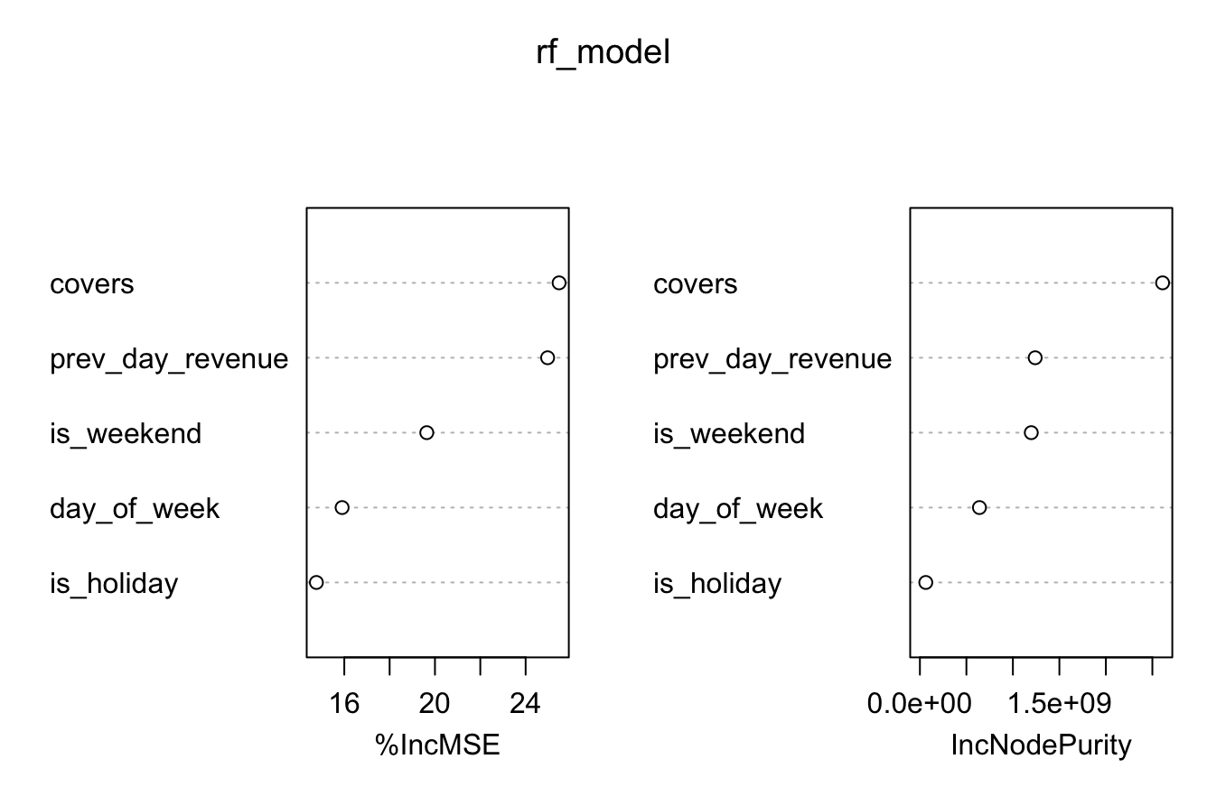
The most influential drivers of revenue are:
- Covers (customer count) – strongest predictor
- Previous day revenue – captures momentum/trends
- Weekend indicator
- Day of week
- Holiday indicator
Business Interpretation: Customer volume (covers) is the strongest driver of revenue, indicating that increasing traffic is more impactful than adjusting pricing strategies. Temporal factors such as weekends and holidays also significantly influence performance, suggesting that staffing and inventory decisions should be aligned with demand cycles. The importance of previous day revenue highlights momentum effects, meaning strong performance tends to carry forward into subsequent days. Overall, revenue is primarily driven by when customers come and how many customers visit, rather than who the customers are.
Conclusion:
Revenue is primarily driven by customer volume and temporal patterns, with strong carryover effects from prior days.

3. Does local status affect customer spending?
A statistical t-test was conducted comparing local vs. non-local customers.
Results:
- Average spend (non-local): $110.16
- Average spend (local): $110.32
- p-value: 0.7129
Conclusion:
There is no statistically significant difference in spending between local and non-local customers.
Customer origin does not meaningfully impact revenue per order.

4. What seasonal patterns affect performance?
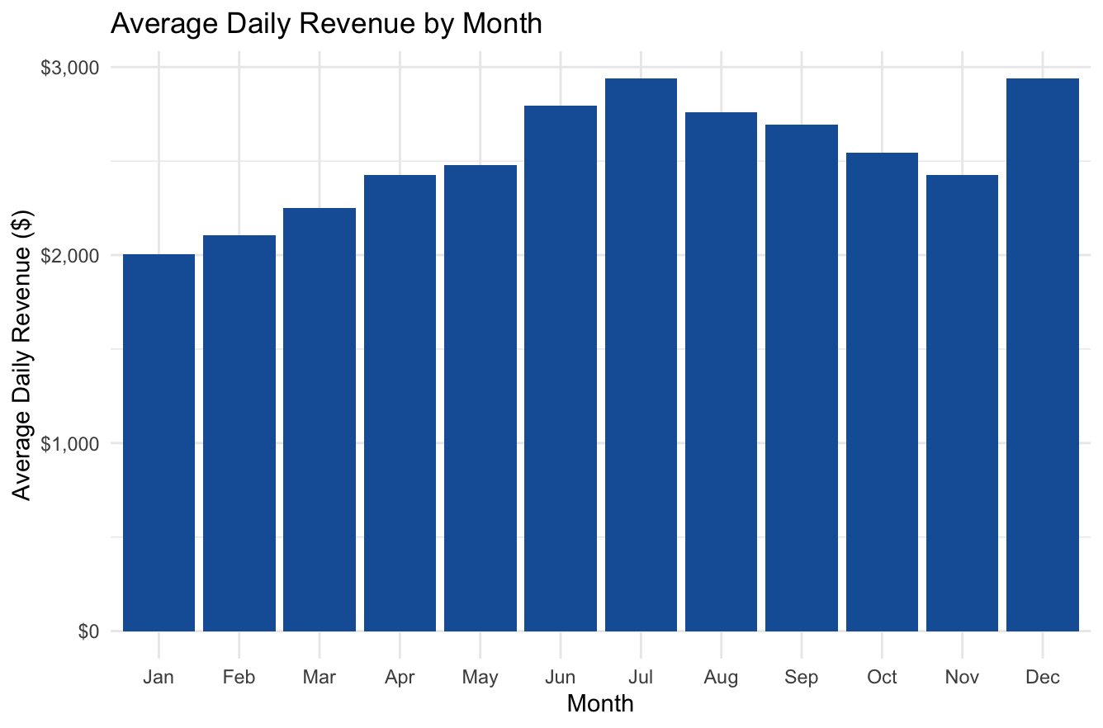
Monthly revenue analysis reveals clear seasonality:
- Peak months: July and December (~$2,938 average daily revenue)
- Lowest month: January (~$2,005)
Interpretation:
- Summer (tourism, dining activity) drives strong performance
- December likely benefits from holidays and celebrations
- Early-year slowdown reflects typical post-holiday decline
Conclusion:
The business exhibits strong seasonal demand, with predictable peaks in summer and holiday periods.

5. What items are commonly bought together by large parties?
Large parties (≥4 people) show distinct ordering patterns.

Top Items:

California Roll | Spicy Tuna Roll | Salmon Nigiri (2 pieces) | Tuna Nigiri (2 pieces) | Edamame
57806 | 45863 | 44115 | 36653 | 34402

Most Common Pairings with California Roll:

Item | Sales Volume
Spicy Tuna Roll | 42,726
Salmon Nigiri (2pc) | 40,876
Tuna Nigiri (2pc) | 33,964
Edamame | 31,847
Miso Soup | 26,704

Conclusion:
Large groups tend to:
- Order shared, familiar items
- Combine rolls + nigiri + appetizers
This suggests strong opportunities for:
- Combo deals
- Group bundles
- Upselling side items

6. Can we identify the COVID shock from channel shifts?
Yes—the data clearly captures the pandemic disruption.
Detected week:
- March 23, 2020
This is identified by a sharp drop in dine-in orders, consistent with lockdown timing.
Conclusion:
The dataset successfully reflects the COVID-19 shock, validating its reliability and capturing a major structural shift toward takeaway/delivery.

7. How have profit margins changed over time?
Comparison of gross profit margins:
- 2015: 68.42%
- 2024: 67.32%
Change:
- Decline of 1.10 percentage points
Conclusion:
Margins have experienced slight erosion, likely due to:
- Rising ingredient costs
- Inflation
- Increased operating expenses
While not severe, this trend should be monitored.

8. Can we forecast 2025–2026 operating profit?
A linear regression model was used to project future profits.

Forecasted Results:
- 2025: $394,099
- 2026: $429,597

Historical Context:
- Strong growth from 2015–2019
- Major drop in 2020 (COVID impact)
- Recovery and stabilization post-2021
Conclusion:
The business is expected to continue growing steadily, surpassing previous profit levels and reaching new highs by 2026.
Limitations
While the analysis provides strong insights, there are several limitations to consider. First, the model does not include external factors such as weather, local events, economic conditions, or competitor activity, all of which may influence customer behavior. Second, the Random Forest model, while accurate, operates as a “black box,” making it less interpretable compared to simpler models. Third, the revenue prediction error indicates that while the model captures trends well, it may not be reliable for precise day-to-day forecasting. Finally, the analysis assumes historical patterns will continue into the future, which may not fully account for structural changes in the business environment.

Final Insights & Recommendations
Final Conclusion
This analysis demonstrates that restaurant performance is highly predictable and primarily driven by customer volume and timing rather than customer type. Seasonality plays a major role, with clear peaks in summer and holiday periods, while external shocks such as COVID-19 can be identified directly through operational data. Importantly, customer origin (local vs. non-local) does not influence spending behavior, indicating that revenue growth strategies should focus on increasing traffic rather than targeting specific customer segments. Overall, the business shows strong long-term growth with stable margins and positive profit projections, suggesting a healthy and scalable operation moving forward.

Key Takeaways
- Revenue is predictable and driven by customer volume and timing
- No difference in spending between local and non-local customers
- Strong seasonality should guide staffing and inventory
- Large parties offer high-value bundling opportunities
- COVID impact is clearly visible and validated
- Margins show minor erosion, requiring attention
- Profit outlook is positive and growing

Strategic Recommendations
- Optimize staffing and inventory for peak months (July, December)
- Create bundled menus for large parties to increase average order value
- Leverage predictive model for short-term operational planning
- Monitor cost structure to prevent further margin decline
- Expand high-margin items (apps, soups, sides) in combos
- Continue strengthening delivery/takeaway channels post-COVID

